1. Refer to "Upgradation Package Demo" folder, you can find the application named "defapp.bin"(must named defapp.bin) in "rom"folder; and voice files or configurations and "data.ini" in "data" folder.

"data.ini" define the data version for Morefun TMS upgradtion.

2. Open the tool.

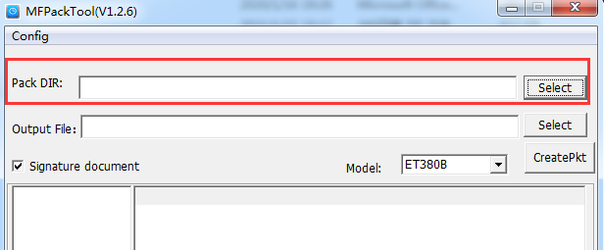

Set the "Pack DIR" with the path of "MF-XDK_ET\tools\Data Upgrade&MFPackTool(EN)\Upgradation Package Demo".

3. Follow the steps here. Set the output file as demo.bin (rename in your need), unselect the signature, select the correct Mode. Then CreatePkt, will export the package file(demo.bin) in the folder with PackDataTool.exe.

